Upgrading the Bowser #1250 HO Scale Trolley Pole!

By John McWhirter & George Huckaby
August 28, 2009

In the early years, HO scale modelers relied on the Bowser trolley pole, which was originally available from Felix Bass’ Pennsylvania Scale Models. When Bowser acquired PSM in the mid-1960s, they continue to manufacture the trolley pole along with the three trolley models, the 1945 all-electric PCC, the 1906 Brill Semi-Convertible and the IRR Lightweight Interurban.

The current Bowser trolley pole was based on a design by George Stock, who was one of the early HO scale traction modelers. The three Bowser trolleys were the only HO scale trolleys commonly available other than the Mantua single truck car available to the traction modeler unless you wished to get a brass model. These brass models were $25.00 to $29.00 each in those days, which we remember being “…a lot of money…” then.

The brass models mostly were imported with a trolley pole using a 1mm pin base, which rotated in a brass turning. The turning was placed in the roof of the car and insulated with a plastic “hat-shaped” insulator. Models imported by Model Tramway, S. Soho, Fairfield Traction Models and more recently MTS Imports, Inc. have used this type of trolley pole. In 2005, Eric Courtney adopted the 1mm pin base for his line of three different HO scale trolley poles.

Custom Traxx and the Southern California Traction Club (SCTC) developed the SCTC1 brass pivot that replicated the pivots used earlier in the hobby. They also developed the SCTC2 insulator for the roofs of metal cars. Both parts are available from Custom Traxx.

In 2008, Bowser upgraded their #1250 trolley pole. They replaced the taco-shaped collector with the NMRA Specification S-5 compliant brass turning, part #12507, and firmer springs, part #12502, both items available from Custom Traxx. However, due to a much more than ample supply, they retained the 3/32” base. The poles have been so improved that we wanted to find a method of converting these poles to the 1mm base so that they could be used with our other cars. Since these poles are produced in the United States and should be readily available, we wanted to try and make this resource usable to all traction modelers.  The package containing the #1250 pole still provides the #1251 roof insulator, a spring, a washer and a 2-56 nut for the original installation method. | 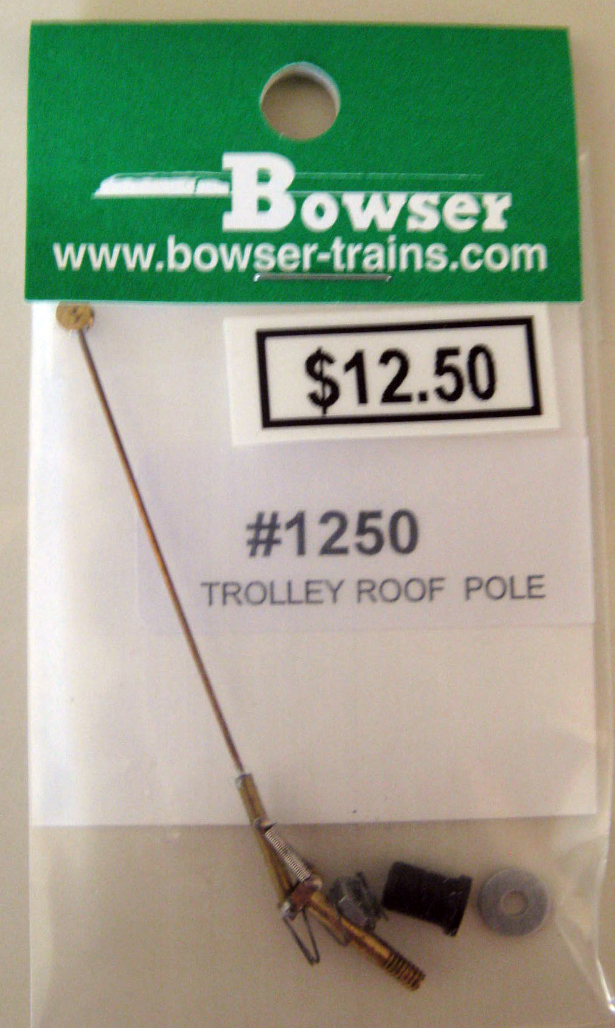

Members of the Southern California Traction Club are constantly looking for innovative ways to make use of any relevant traction equipment. Over the years, large numbers of old style Bowser trolley poles (See Fig. 1 on next page) had been put aside in favor of poles with 1mm bases that fit into the SCTC1 trolley base bushings. In an effort to supplement the currently available poles crafted by Eric Courtney, a procedure has been developed to convert the old Bowser poles to fine new ones.

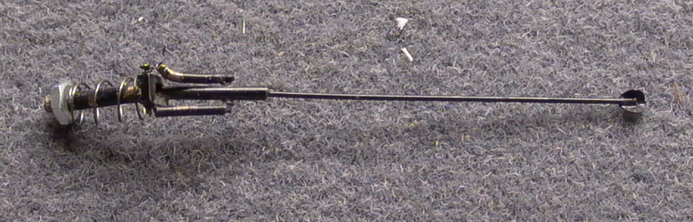
Fig. 1 Original Bowser pole.

The process that we have developed is presented step-by-step:  1. Strip off the old weak springs and discard.  2. Unsolder the old trolley pole from the pivot base.  - Unsolder and remove the small pins that formally held the ends of the springs.  Note: Do not remove the pivot pin.  4. Use a Dremel cut-off wheel to cut off the existing 3/32” screw base flush with the bottom of the pivot base.  5. Center punch a mark to allow for drilling a new hole through the pivot base.  6. Drill a No. 60 (0.040 inch) hole through the pivot base. See Fig. 2 at right and the drilled base in Fig. 3 on next page: | 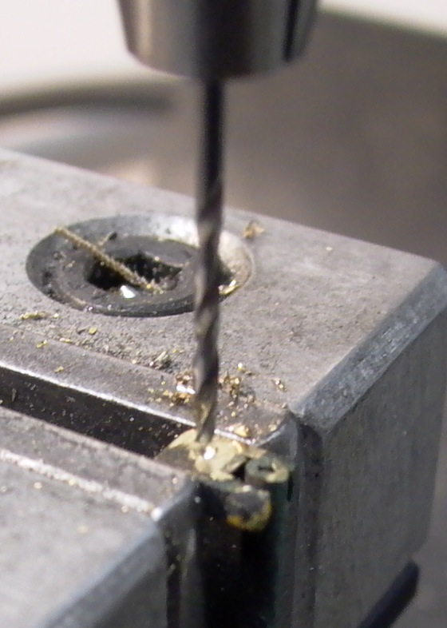  Fig. 2 Drilling No. 60 hole in pivot base.

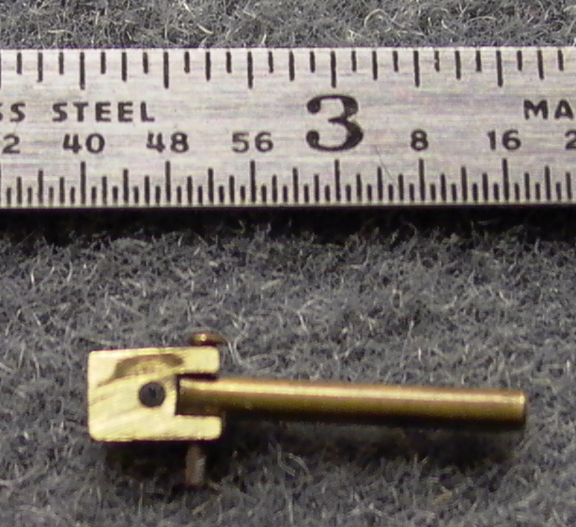
Fig. 3 Pole pivot base with .040 hole for new pin base.

- Cut and bend a 1/2-inch length of .040 brass wire as shown below in Fig. 4.

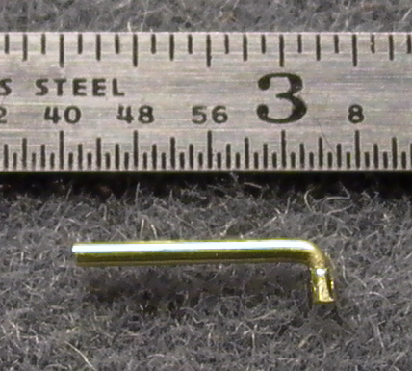
Fig. 4 .040 brass wire cut and bent into an “L” shape.

8. Insert this pin through the pivot base from the top and solder in place. This pin becomes the new pole base and the bend on top serves as a stop for the pole arm. The stop prevents the pole from elevating more than 90 degrees from the horizontal. We will be replacing the Bowser pins with hooks to hold the springs. The small 90-degree extension of the pin will allow the springs to be replaced without the use of a soldering iron and preventing the trolley pole from rising beyond 90 degrees will prevent the loss of springs. See Fig. 5 below:

9. Drill through the existing holes in the base and pivot arm to allow for new pins to hold the new springs. Use a No. 76 (0.020 inch) drill.  Note: When you are drilling the existing holes in the base, you will be drilling partially through the shaft that you fabricated, inserted and soldered. Take extreme care that your drilling exits the hole on the other side and that you are not drilling another hole.  10. Cut two ½” sections of .019” brass wire  11. Insert and solder one of these sections in the trolley pole base and the other in the trolley pole mount. Leave equal amounts of wire available on either side.  12. Form hooks for the springs in both wires.  Note: Do Not install springs until after step 13 has been completed!  13. Insert and solder new .020 spring steel wire as a new pole in the pivot arm. Note Fig. 6 on next page.  - Install new Bowser 12502 or other trolley pole springs. Then clip off any excess material, leaving just enough to hold the springs firmly in place. | 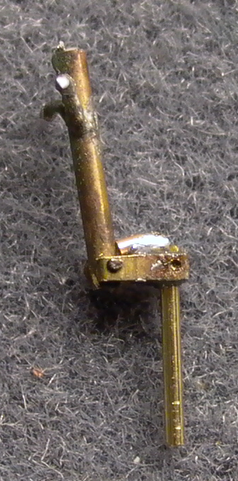  Fig. 5 New brass pole pin and angle stop.

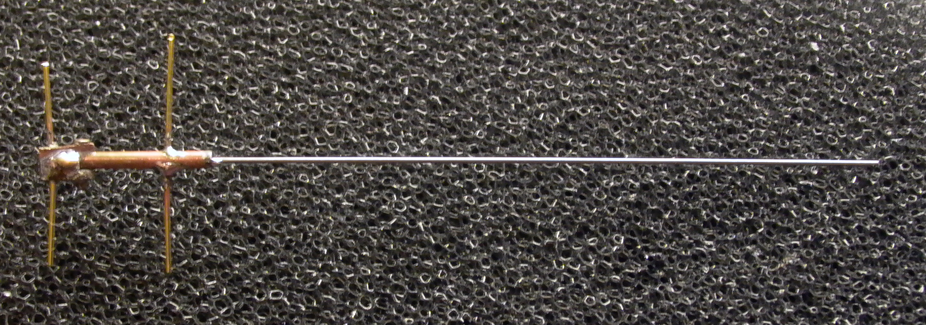
Fig. 6 Steel pole wire and brass spring wires soldered in place.

- Solder new Bowser 12507 wheel turning, Precision Scale wheel or shoe castings, or Miniatures by Eric wheel or shoe castings on end of pole to create a 15-foot pole assembly. Be sure to drill castings with a #76 drill to ensure a good fit onto the pole stock. Fig. 7 shows a completed pole with Bowser 12502 springs and a 12507 contactor.

Note: The 15 foot measurement is taken from the pivot point in the base to the end of the trolley pole stock, not including any shoe or wheel casting or turning.

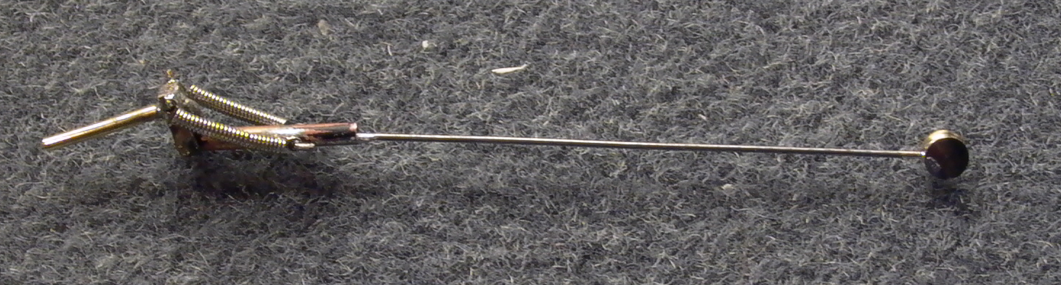
Fig. 7 Finished pole with Bowser S-5 compliant contactor and new Bowser springs.

The next photo shows many poles converted and assembled using various collectors. All of these poles are now on various pieces of equipment running on SCTC modules. Collectors shown on these poles consist of the Miniatures by Eric trolley shoes, The Bowser 12507 contactor and the Miniatures by Eric HT-C3 wheel casting.

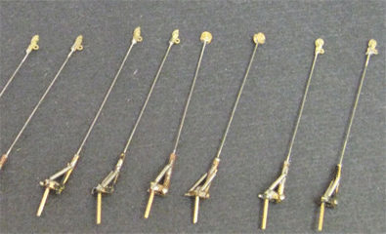
Fig 8 SCTC upgraded Bowser poles.

Evaluation of these poles under operation in both the DC and DCC environments is continuing……….

