IMPRESSIONS OF THE SCTC LAYOUT AT THE NATURAL HISTORY MUSEUM

During the September 8-9, 2007 display of the club at the Natural History Museum, we encountered many people that we would not normally see at model train shows. Among these were artists just sitting around with their sketch pads. Most of them were sketching different animals in the various displays. One young woman was a second grade teacher from the Los Angeles United School District. Another young woman we encountered was Jill Takemiya, a sophomore at the Otis College of Art & Design in the Westchester of Los Angeles. She sketched three different areas of the layout. The first was the Palms Depot, located just outside the town of Garcia on module 965. This structure had been provided by Alpine Division Scale Models when the module was first built in 1996.

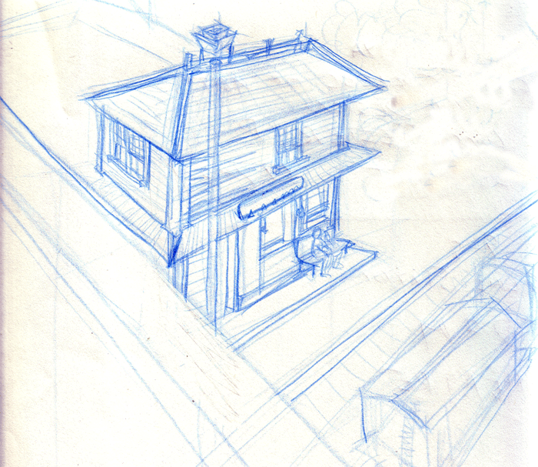

Jill also captured the intended speediness of Columbus, Delaware and Marion 500, while on a siding on module 972. CD&M 500 was one of two parlor cars used by the railroad for fast comfortable service.

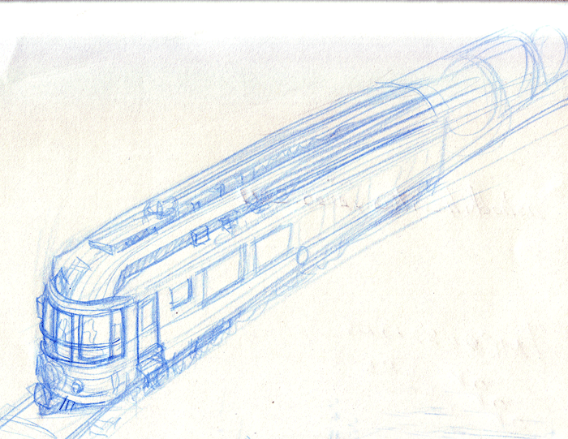

Jill’s final sketch was of the Palace Theater on module 010. This structure is essentially a Walthers Built-up Structure 933-2817 with some modifications by the club.

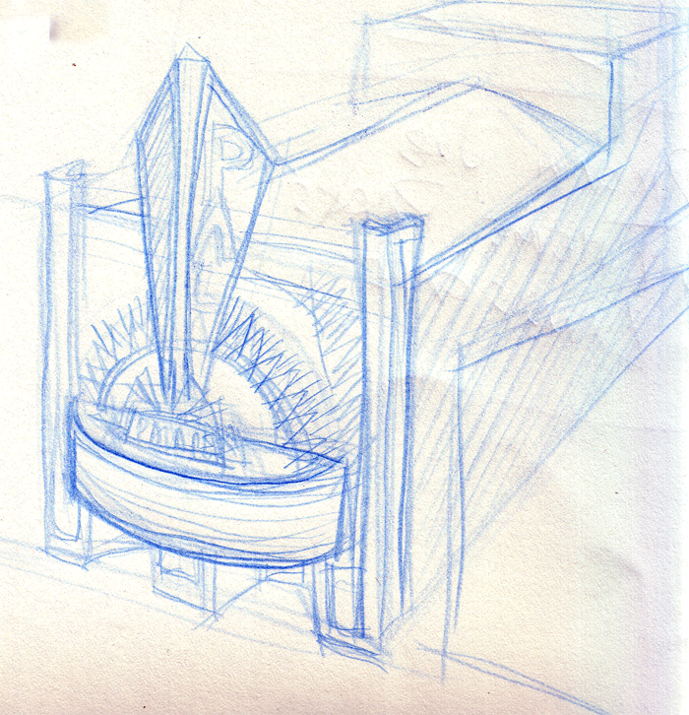

Displaying model trains at public gathering does not produce boredom! Another young visitor, Jackson Oakley, one of two sons of Wesley Oakley, the audio-visual specialist that illuminated our display enjoyed our layout so much that he insisted on presenting the trolley car coloring to George Huckaby before he left for the afternoon. Jackson spent the entire afternoon walking around the layout following Suydam Pacific Electric Railway 717 as it made its way around the display. He followed that car at least fifteen times around the entire layout before he got tired. Jackson was typical of many younger visitors who had never seen anything like this. Unless a member of your family is into model railroads, you might never see anything like this. The display was definitely a hit with all ages!

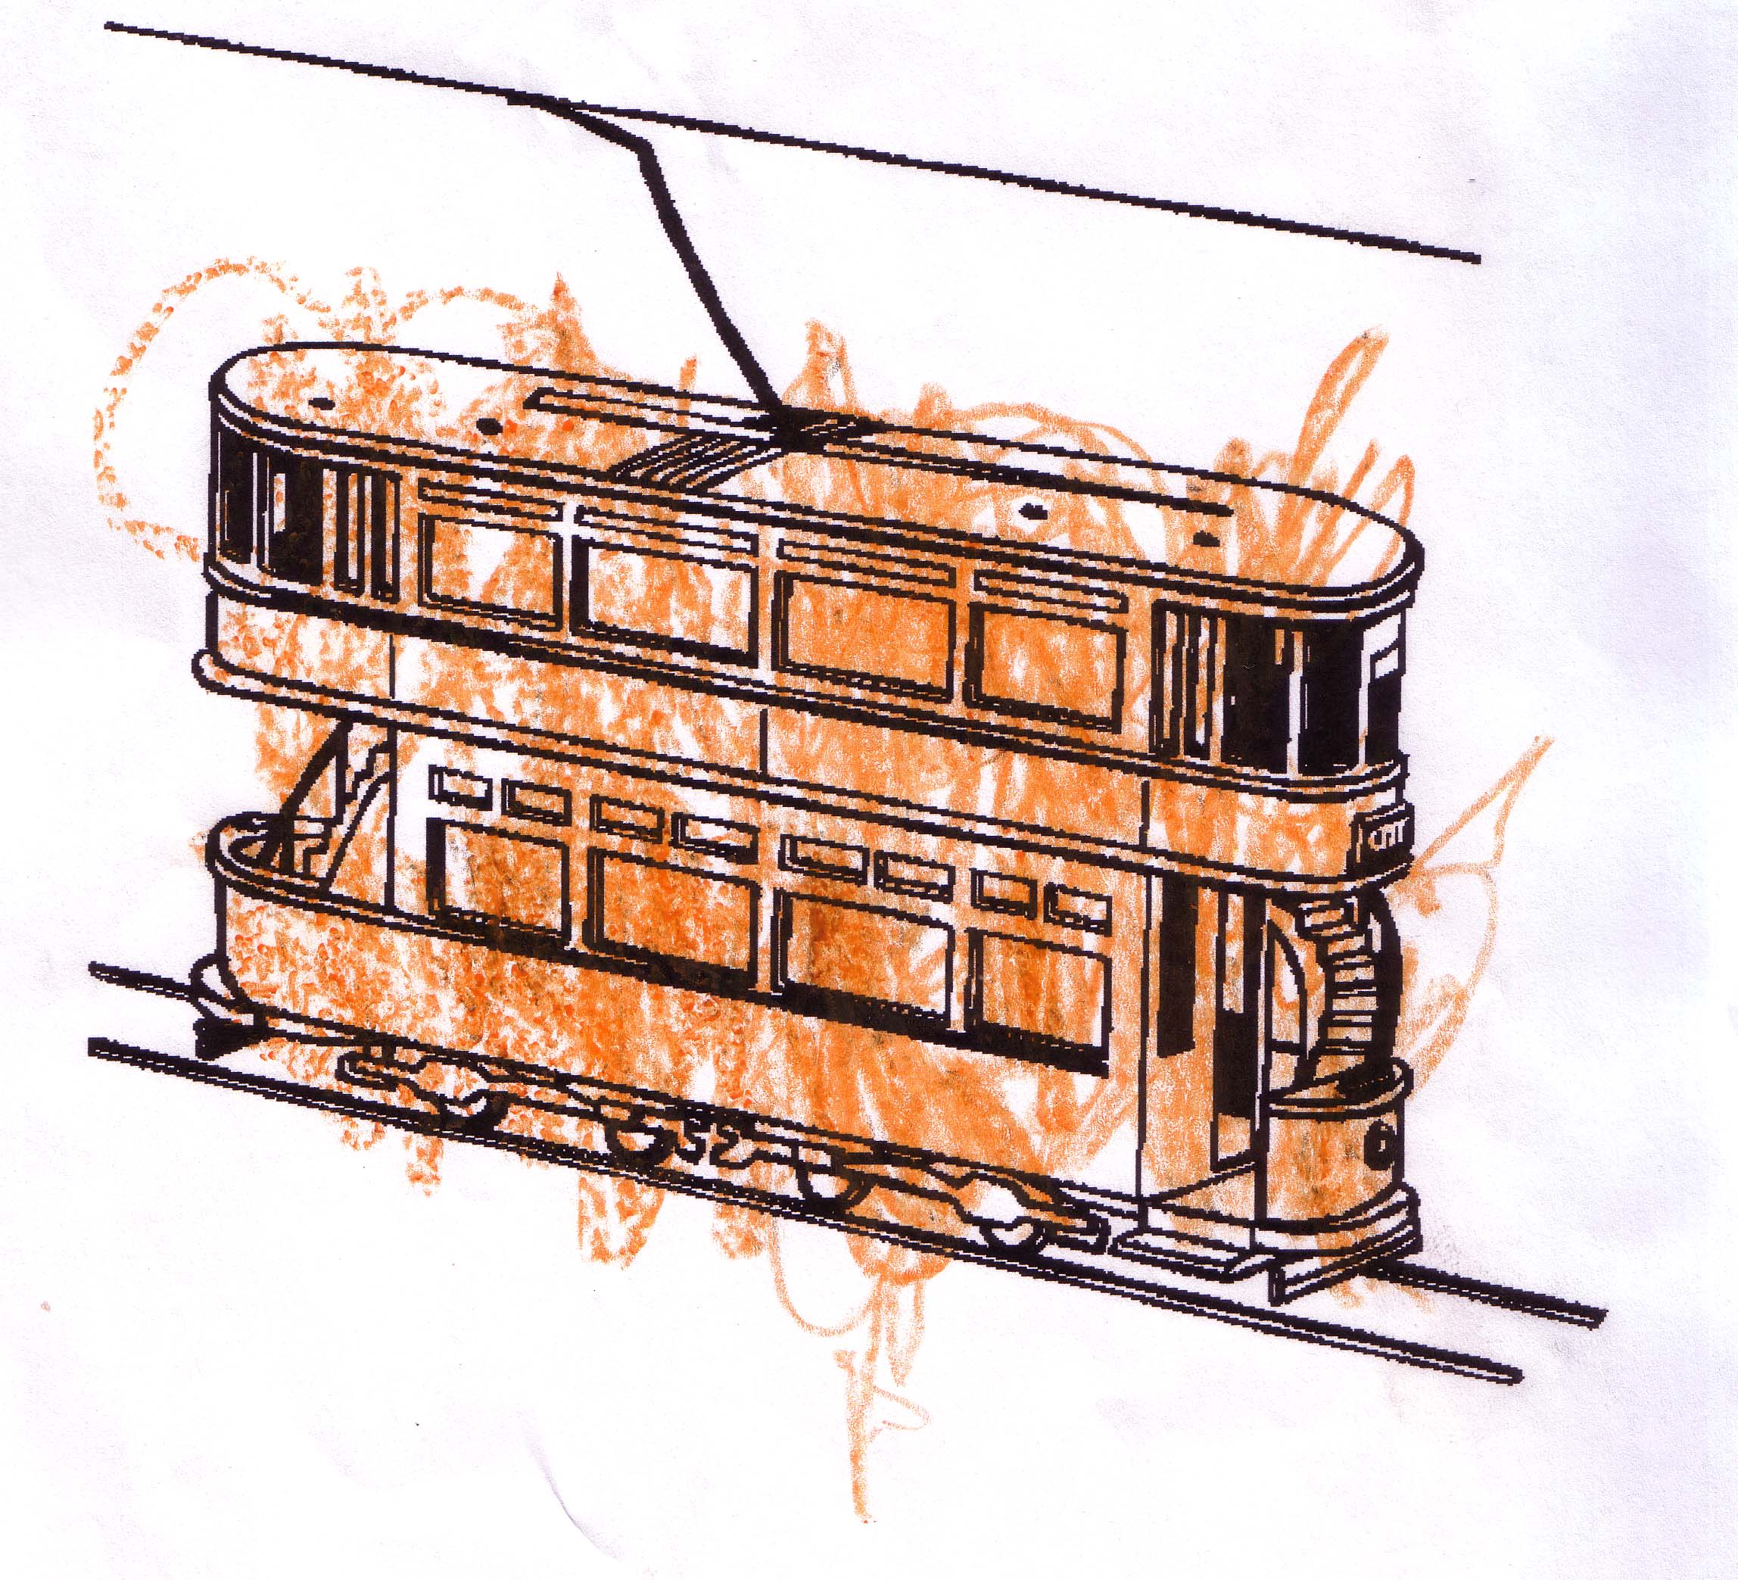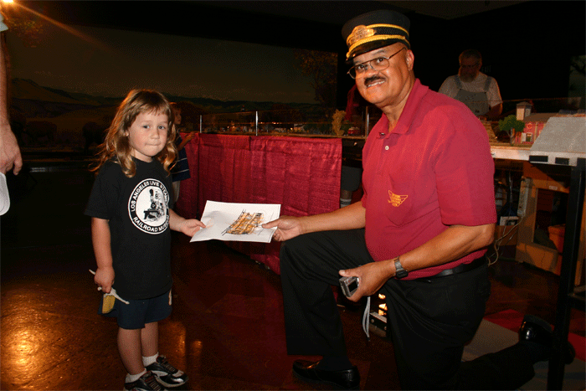

Jackson Oakley was so enthusiastic about the display that he got out the crayons and colored a trolley car and presented it to George Huckaby toward the end of the last day of the display. The reaction to our display was intense at times and the club was placed on notice that the museum would like to have the club back for an entire week in the near future.

